SIMATS ENGINEERING
Assessment Tool 2 – Data Interpretation (Medium)
Course: Internet Programming (CSA43) | CO-1 | Total Marks: 20
Name / Reg No: Vijayan P (192525312)

1. HTTP Response Analysis
HTTP/1.1 200 OK
Date: Mon, 01 Apr 2026 10:00:00 GMT
Content-Type: text/html
Content-Length: -150
Connection: keep-alive
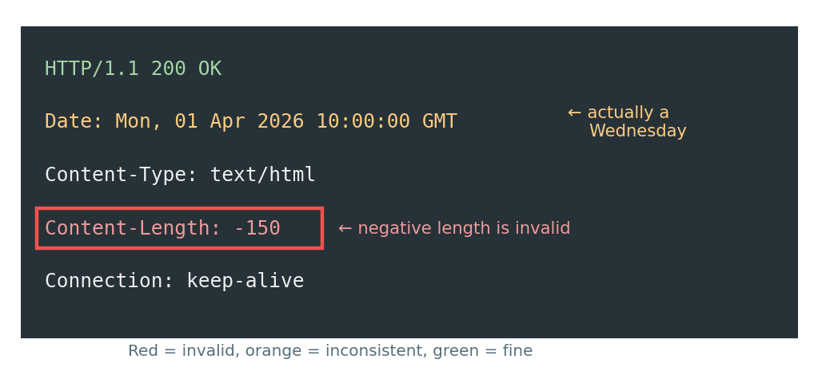
Figure 1: The response header with the faulty fields marked

1) Incorrect or invalid fields
- Content-Length: -150 is the clear error. The length of a body is a count of bytes, so it has to be zero or a positive whole number. A negative value is not allowed by the HTTP/1.1 spec.
- Date is also wrong, though it is easy to miss. 1 April 2026 falls on a Wednesday, not Monday, so the day name and the date do not agree. Browsers usually ignore this, but it is still an invalid date value.
- The status line, Content-Type and Connection are all well-formed.

2) Issue with Content-Length and its impact
Content-Length tells the client exactly how many bytes of body to read before the message ends. With keep-alive, the same TCP connection is reused for the next request, so the client depends on this number to know where one response stops and the next starts.
- A negative number cannot be used to read anything, so the client treats the response as malformed and may drop it or close the connection.
- The page may fail to load, load only partially, or the browser may keep waiting for data.
- Because the connection is being reused, a wrong length can mix up later responses on the same connection. This is the basis of HTTP request smuggling, so it is a security problem as well and not just a display problem.

3) Does the status code match the response?
Not really. 200 OK says everything went fine, but the header itself is broken, so the response is not actually correct. A server that knows it produced a bad response should not send 200. In practice a proxy or client would reject this message, and a gateway usually answers with 502 Bad Gateway. If the server itself failed while building the response, 500 Internal Server Error is the honest code. The best fix is to avoid the problem and send 200 with a correct length.

4) Corrections
HTTP/1.1 200 OK
Date: Wed, 01 Apr 2026 10:00:00 GMT
Content-Type: text/html; charset=UTF-8
Content-Length: 150
Connection: keep-alive

- Set Content-Length to the real size of the body in bytes (150 here only as an example). Let the server framework calculate it instead of typing it by hand.
- Fix the weekday to Wed (or just let the server generate the Date header).
- If the size is not known in advance, drop Content-Length and use Transfer-Encoding: chunked.
- Adding charset=UTF-8 to Content-Type is a good habit though not an error.

2. DOM Structure Analysis
<html>
<head>
<title>TestPage</title>
</head>
<body>
<div>
<p>HelloWorld
</div>
</body>
</html>
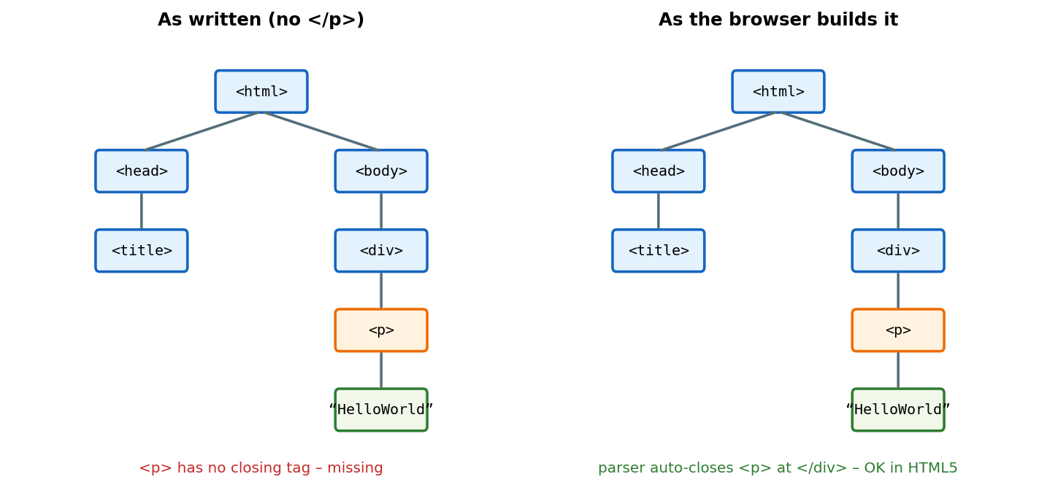
Figure 2: DOM tree as written and as the browser builds it

1) Missing or improperly closed elements
- The <p> tag is never closed (</p> is missing).
- There is no <!DOCTYPE html> at the top, so browsers fall back to quirks mode.
- Smaller things: no lang attribute on <html> and no <meta charset> in the head.
All the other tags (html, head, title, body, div) are opened and closed properly.

2) How the browser interprets it
HTML parsers are forgiving. In HTML, the end tag of <p> is optional, so when the parser reaches </div> it sees that a <p> is still open and closes it automatically. The result is the same tree as in the right half of the figure: html → head/body, body → div → p → text “HelloWorld”. No error message is shown to the user.

3) Impact on rendering and layout
- In this small page, almost nothing changes visually, because the auto-closed <p> ends exactly where the author wanted it to.
- Missing DOCTYPE puts the page in quirks mode, so box sizes, fonts and margins can render slightly differently across browsers.
- In bigger pages, an unclosed tag can swallow the following content into the wrong parent, which breaks spacing, CSS selectors and JavaScript DOM lookups.
- If this were served as XHTML/XML, the missing </p> would be a fatal well-formedness error and the browser would show an error instead of the page.

4) Corrected version
<!DOCTYPE html>
<html lang="en">
<head>
<meta charset="UTF-8">
<title>TestPage</title>
</head>
<body>
<div>
<p>Hello World</p>
</div>
</body>
</html>

3. GET vs POST in a Login System
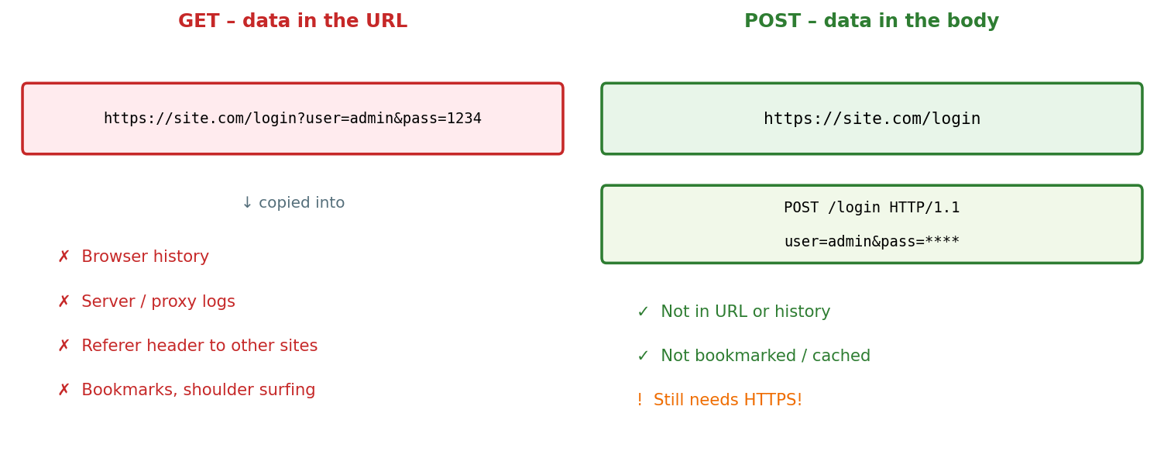
Figure 3: Where the credentials end up with GET and with POST

1) Differences in data transmission
Point | GET | POST
Where data goes | Appended to the URL as a query string | Sent inside the request body
Visibility | Visible in address bar | Not shown in the URL
Stored in | History, bookmarks, server logs, cache | Not stored in history or bookmarks
Size limit | Limited by URL length | Practically no limit
Intended use | Fetching or reading data (safe, repeatable) | Sending data that changes something

2) Which method suits login
POST is the right choice. Login sends a username and password, which are private and trigger a server action (creating a session). POST keeps them out of the URL, so they do not get saved in history, bookmarks or casual logs. GET is meant for harmless lookups, and it is also cached and repeated freely by browsers, which is the opposite of what we want for credentials.

3) Security risks of using GET for authentication
- Password appears in the address bar, so anyone looking over the shoulder can read it.
- It stays in browser history and bookmarks, and on shared computers the next user can see it.
- Web server, proxy and firewall logs record full URLs, so the password gets written to plain-text logs.
- The Referer header can leak the URL (with credentials) to other sites when the user clicks an external link.
- URLs can be cached, shared in chats or prefetched by browsers, and the same login link could be replayed.
Note that POST on its own is not “secure”, it only hides the data from the URL. The table in the question rates it as moderate, and that is fair.

4) Best practices for secure login
- Use POST over HTTPS (TLS) always, so that the body is encrypted in transit.
- Store passwords hashed with a slow salted algorithm such as bcrypt, Argon2 or PBKDF2, never in plain text.
- Use CSRF tokens, secure session cookies (HttpOnly, Secure, SameSite) and regenerate the session ID after login.
- Limit login attempts or add a lockout/CAPTCHA to slow down brute force, and consider two-factor authentication.
- Use prepared statements to prevent SQL injection and give generic error messages (“invalid username or password”).
- Do not log passwords and do not put them in URLs or hidden fields.

4. HTML Code Inspection
<!DOCTYPE html>
<html>
<head>
<title>Sample</title>
</head>
<body>
<h1>Welcome
<p>This is a paragraph
<img src="image.jpg">
</body>
</html>
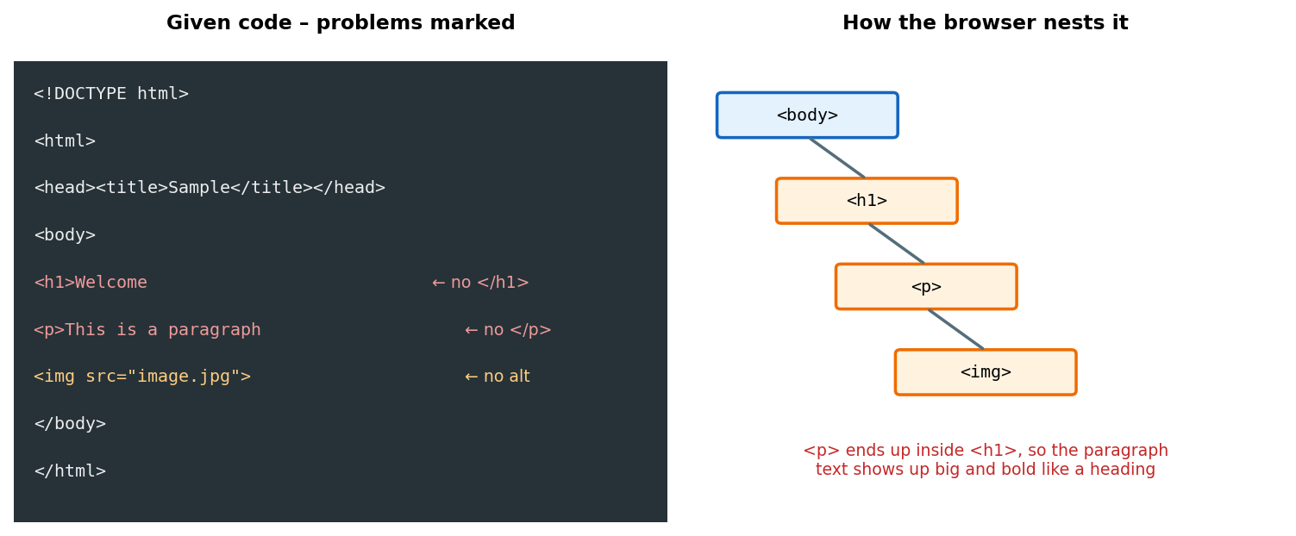
Figure 4: Problems in the snippet and how the browser nests the tags

1) Missing closing tags
- <h1> has no </h1>.
- <p> has no </p>.
<html>, <head>, <title> and <body> are closed correctly. <img> does not need a closing tag in HTML5.

2) Issues with the <img> tag
- No alt attribute. This is required for valid HTML and for accessibility, because screen readers and broken-image fallbacks use it.
- No width and height, so the page layout can jump when the image finishes loading.
- It is an empty (void) element, so it is fine without </img>. In XHTML it must be self-closed as <img ... />.
- If image.jpg is not found, the user only sees a broken-image icon, and without alt text there is nothing to explain it.

3) How browsers handle these errors
Browsers do not stop on these mistakes, the HTML5 parsing algorithm repairs them. The key point is that a new <p> does not close an open <h1>, so the paragraph gets nested inside the heading. Both stay open until </body>, where the parser closes everything automatically. So the paragraph text and the image end up inside <h1> and appear in large bold heading style, which is not what the author intended. The page still displays, but the structure is wrong, and it hurts accessibility and SEO.

4) Corrected code
<!DOCTYPE html>
<html lang="en">
<head>
<meta charset="UTF-8">
<title>Sample</title>
</head>
<body>
<h1>Welcome</h1>
<p>This is a paragraph</p>
<img src="image.jpg" alt="Sample image" width="300" height="200">
</body>
</html>

5. Browser–Server Communication Flow
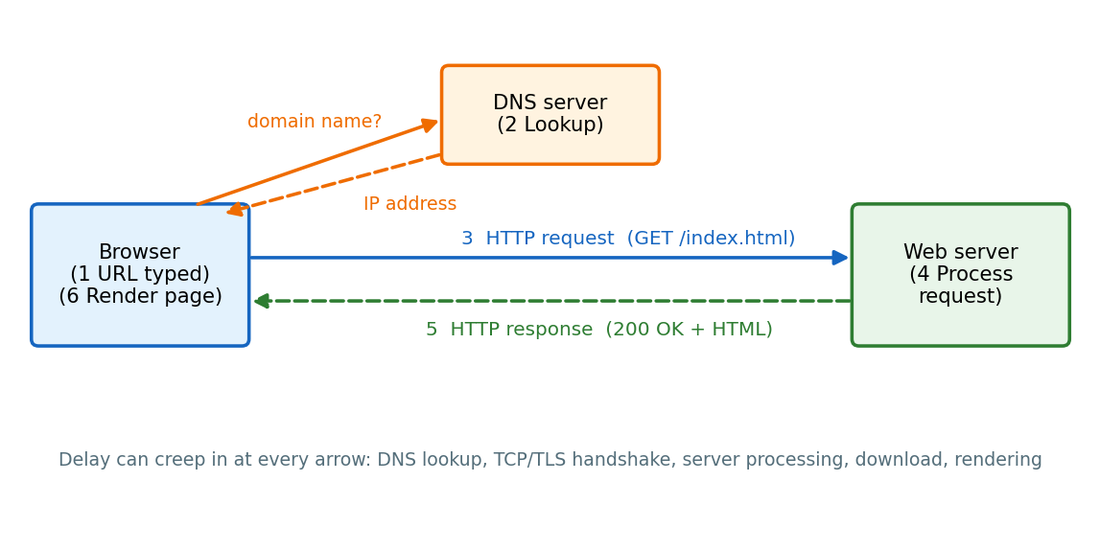
Figure 5: Request flow between browser, DNS server and web server

1) Each step
# | Step | What happens
1 | User enters URL | Browser reads the scheme (http/https), domain, path and port. It checks its cache for a stored copy of the page first.
2 | DNS lookup | The domain name (e.g. www.example.com) is converted to an IP address. Browser/OS cache is checked first, then the DNS resolver.
3 | HTTP request sent | A TCP connection (plus TLS handshake for HTTPS) is opened to the IP, and a request such as GET /index.html with headers is sent.
4 | Server processes request | The server finds the file or runs server-side code, may query a database, and prepares the response.
5 | Response returned | Server sends a status line (e.g. 200 OK), headers and the body (HTML). Browser later fetches CSS, JS and images with more requests.
6 | Browser renders page | HTML is parsed into the DOM, CSS into the CSSOM, they combine into a render tree, then layout and painting happen. JavaScript runs along the way.

2) Where delays can occur
- DNS lookup: slow or distant resolver, no cached entry.
- Connection setup: TCP and TLS handshakes add round trips, worse over long distances.
- Server processing: heavy database queries, slow code, overloaded server.
- Network transfer: large files, low bandwidth, packet loss.
- Rendering: big images, render-blocking CSS/JS, too many extra requests.

3) Role of DNS
DNS works like the phonebook of the internet. People remember names like example.com, but machines communicate with IP addresses. Without DNS the browser would not know which server to contact, so nothing can be requested at all. The lookup goes through the browser cache, the OS cache, the recursive resolver (usually the ISP), and, if needed, root, TLD and authoritative name servers. Once the IP is found, it is cached for the TTL period so the next visit skips this step. A DNS failure shows up as “server not found”, even if the website itself is up.

4) Optimizations
- Use a fast DNS provider, a sensible TTL and dns-prefetch hints for third-party domains.
- Serve content through a CDN so the server is physically closer to the user.
- Enable HTTP/2 or HTTP/3, keep-alive connections and TLS session reuse to cut handshakes.
- Use browser caching (Cache-Control, ETag) and server-side caching; optimise database queries.
- Compress with gzip/Brotli, minify CSS/JS, compress images (WebP) and lazy-load below-the-fold images.
- Reduce the number of requests and avoid render-blocking scripts (defer/async).

Code of Conduct
I Vijayan P (Name / Reg No) certify that this submission is my original work and that I have adhered to the guidelines specified for this assessment. I understand that any violation of academic integrity rules will result in disciplinary action.
Signature of the student: Vijayan P

